Chapter 3

An Introduction to Machine Learning

3.1 Introduction

The title of most important and significant discovery of this millennium, can rightly fully be bestowed upon, the invention of Computers. The invention of computers has blessed mankind with speed and accuracy. And ever since invention of computers, started the initiative for making them smarter - by making them learn and do thing on their own. The biological definition of learning includes phrases such as to acquiring knowledge, or understanding of, or skill in, by study, instruction, or experience," and modification of a behavioral tendency by experience. Making machines learn has been a tough task. Scientist believed that a successful understanding of how to make machines (computers) learn would open up many new ideas and new level of competence and customization.
In the beginning many practical computers programs have been developed to exhibit useful type of learning and significant commercial application. But since the focus was given on manually programming computers, the performances of such methods were low. I.e. for any performance improvement a new program has to written or existing programs had to be modified.
Making the machines learn like humans had been a fully elusive goal until the new idea of machine learning was introduced by Turing in 1948. Since then there was a splurge in machine learning algorithms and methodologies. Machine Learning focused on the question of how to adjust the behavior of a program dynamically by using statistical techniques. Thus it would be true to say that Machine Learning is a natural outgrowth of the intersection of Computer Science and Statistics [8]. It is true to say that, a machine (computer) is said to have learned a process, when it conceives the capability to take decisions without human intervention. The machine learning algorithms outperformed all other approaches that have been attempted to date. However, till date the insights machine learning has gained from the study of Human Learning process are much weaker than those it has gained from Statistics and Computer Science, due primarily to the weak state of our understanding of Human Learning.
Note
A 10 day old baby easily figures out his mother more quickly and effectively than a well trained computer.

According to Tom Mitchell “A machine is said to learn with respect to a particular task T, performance metric P, and type of experience E, if the system reliably improves its performance P at task T, following experience E. Depending on how we specify T, P, and E, the learning task might also be called by names such as data mining, autonomous discovery, database updating, programming by example, etc. [11]. He said that, to have a well defined learning process one must identify the following features.

- The source of experience
- The class of task
- The measure of required performance improvement
The term experience here refers to set of those instances for which an outcome is known. Usually for some machine learning problem this part has to be supplied from the human side. Unsupervised machine learning algorithms does not require this support. There should be clear idea about the number of different classes or outcomes which are possible. Also there should be some parameter which helps in the measurement of performance of the system.
3.2 Why should machines learn?

Here are some of the reasons:

- There are situations where it is not possible to obtain required accuracy in doing a job just by providing a static set of rules to the computer. One of them would be human language translation where it is very difficult to obtain any perfect relation for conversion between the two languages. In that case we would like machines to be able to adjust their internal structure to produce correct outputs for a large number of sample inputs and thus suitably constrain their input/output function to approximate the relationship implicit in the examples.

- When the application is too complex for people to manually design the algorithm. For example, software for sensor-base perception tasks, such as speech recognition and computer vision, fall into this category. All of us can easily label which photographs contain a picture of our mother, but none of us can write down an algorithm to perform this task. Here machine learning is the software development method of choice simply because it is relatively easy to collect labeled training data, and relatively ineffective to try writing down a successful algorithm[12]

- As per fourth paradigm studying any process can be done through data centric method. Here the main stress is given on understanding or mining out important relationships and correlations hidden in large piles of data. Machine learning methods can often be used to extract these relationships (data mining).[11]

- In situations where the environments change over time, it is impossible to provide all possible set of instructions of how to react when an environmental parameter changes. Machines that can adapt to a changing environment would reduce the need for constant redesign. [12]

- When the characteristics of the environment are not fully understood or not available. A machine can be built using the available knowledge of the environment and then machine learning methods can be used for on-the-job improvement of existing machine designs.[11]

- The amount of knowledge available about certain tasks might be too large for explicit encoding by humans. Machines that learn this knowledge gradually might be able to capture more of it than humans would want to write down.[11]
3.3 Data Mining – An Introduction
It is of no doubt that, Information is the driving force of the world. But what is information: To be exact, it is a collection of meaningful data. Each day the world of computing is manipulating on billions of data to extract some information from them. But take it for granted, that Information extraction is not so easy task. Most of the Information is hidden in these data. It is found that these information itself have a pattern inbuilt in them and if we could discover this pattern we would be in a position to predict information without actually going through all the data(if available) . Wouldn’t it have been better if we have some process by which we can optimally find out a pattern in the information? These patterns, associations, or relationships among all this data can provide further information. Thus in abstract, Data mining is an art of the extraction of hidden predictive information from large data sources.
Let’s take an example from the astronomical domain. The Earth is the only planet known to have life in it. But it is a fact that it is facing threats from the cosmological objects and events, like meteors most of which are coming from the meteor belt, on the outer orbit of solar system, In order to prevent such accidents from happening, our sky is being scanned continuously in all directions, so that any such threat can be easily predicted and avoided by slightly changing the speed or trajectory of the meteor by some means. This amount of such data collected by the ground based and space based antennas are very large that they cannot be processed at that instant. They are collected to a database and then they are processed for any valid information.(any direct or indirect threat). Also the information extraction has to be very fast in order to cope up with the rate of data collection. This is where the power of data mining shows up. Without data mining algorithms it would not have been possible to extract the information from this data. Like this there is N number of examples that you could project out.
3.4 Machine learning & Data Mining
Creating intelligent machines has been central to robotic research right from the beginning. Intelligence is required for robots to be able to handle such tasks as object manipulation and navigation, with sub-problems of localization, mapping and motion planning. Artificial intelligence (AI) is the intelligence of machines and the branch of computer science that aims to create it. Machine learning is one of the main application domains of data mining. An intelligent agent is a system that perceives its environment and takes actions which maximizes its chances of success. Thus Knowledge representation and knowledge engineering are central to AI research i.e. Many of the problems machines are expected to solve will require extensive knowledge about the world. These knowledge discovery from the vast amount of data is a hectic process and this is where data mining helps [7].

Fig 3.1: TOPIO, a humanoid robot, played ping pong at Tokyo International Robot Exhibition (IREX) 2009

3.5 Data Mining Schemes
There a number of methods that we can adopt to retrieve the information about information (Information patterns). Data Mining can be done in various algorithms. They include the following.
- Artificial Neural Networks (ANN): A neural network is a parallel system, capable of resolving paradigms that linear computing cannot. These are non-linear predictive models that learn through training and resemble biological neural networks in structure. This text explains the Data mining concepts in this platform [6].
- Decision Trees: A decision tree is a decision support tool that uses a tree-like graph or model of decisions and their possible consequences, including chance event outcomes, resource costs, and utility. Tree-shaped structures that represent sets of decisions. These decisions generate rules for the classification of a dataset. Some of the decision tree methods include Classification and Regression Trees (CART) and Chi Square Automatic Interaction Detection (CHAID) [6].
- K-Nearest Neighbor Method: The idea behind is technique is that, it classifies each record in a dataset based on a combination of the classes of the k record(s) most similar to it in a historical dataset. It is sometimes referred to as the k-nearest neighbor technique [6].
- Rule induction: Rule induction is one of the most important techniques of machine learning. Since regularities hidden in data are frequently expressed in terms of rules, rule induction is one of the fundamental tools of data mining. Usually rules are expressions of the form
If (attribute − 1; value − 1) and (attribute − 2; value − 2) and ……..
and (attribute − n; value − n)
Then (decision; value)
- Genetic Algorithms: The basic concept of GAs is designed to simulate processes in natural system necessary for evolution, specifically those that follow the principles first laid down by Charles Darwin of survival of the fittest. It is basically an intelligent exploitation of a random search within a defined search space to solve a problem. They involve optimization techniques that use processes such as genetic combination, mutation, and natural selection in a design based on the concepts of evolution.
- Support Vector Machines (SVM): The original SVM algorithm was invented by Vladimir Vapnik and the current standard incarnation (soft margin) was proposed by Corinna Cortes and Vladimir Vapnik. Support Vector Machines are a useful technique for data classification. A Support Vector Machine performs classification by constructing an N-dimensional hyper plane that optimally separates the data into N categories, where N is the number of available classes. SVM models are closely related to neural networks. In fact, a SVM model using a sigmoid kernel function is equivalent to a two-layer, perception neural network[6].

3.6 How it works?
How exactly is data mining able to tell you important things that you didn't know or what is going to happen next? The technique that is used to perform these feats in data mining is called Modeling. Modeling is simply the act of building a model in one situation where you know the answer and then applying it to another situation that you don't. But in order to construct a model we need to analyze the relationships and patterns in stored data. Generally four types of relationships are traced:-
- Classes: Stored data is used to locate data in predetermined groups. For example, a restaurant chain could mine customer purchase data to determine when customers visit and what they typically order. This information could be used to increase traffic by having daily specials.
- Sequential patterns: Data is mined to anticipate behavior patterns and trends. For example, an outdoor equipment retailer could predict the likelihood of a backpack being purchased based on a consumer's purchase of sleeping bags and hiking shoes.
- Clusters: Data items are grouped according to logical relationships or consumer preferences. For example, data can be mined to identify market segments or consumer affinities.
- Associations: Data can be mined to identify associations. For example, on analyzing large amount of medical data if it is found that a particular drug for Thyroid is causing side effects for large number of patients. It can be strictly commented that the particular drug should not be taken.
All data have some unique features based on which the classification, pattern reorganization or clustering can be done. All these relationships and patterns are traced based on some unique features of the data. Once you find out this features based on which the relationships and patterns in the data can be traced, an accurate model which works on or manipulates on these feature values can be developed by various implementation schemes mentioned earlier in this chapter [6].
NOTE
Whatever be the case, the computers cannot do without humans. For implementing a Data mining algorithm (supervised), the first and foremost requirement is collection of valid data. And this has to come from human side. Once the data is made available the rest is left to the algorithm.

3.7 Instances & Features
The standard model of structured data for data mining is a collection of cases (examples or instances). Potential measurements called features are specified, and these features are uniformly measured over many cases. Usually the representation of structured data for data-mining problems is in a tabular form or in the form of a single relation (term used in relational databases), where columns are features of objects stored in a table and rows are values of these features for specific entities. A simplified graphical representation of a data set and its characteristics is given in Fig. 3.2. In the data mining literature, we usually use the terms samples or cases for rows. Many different types of features (attributes or variables), i.e., fields-in structured data records are common in data mining. Not all of the data mining methods are equally good at dealing with different types of features [6].
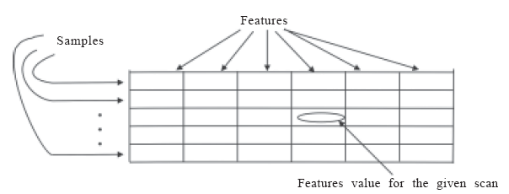
Fig. 3.2: Representation of objects (samples) using features.
Figure 3.3 and Table 3.1 illustrate the concept of instances, features and structured data format in a more concrete way.

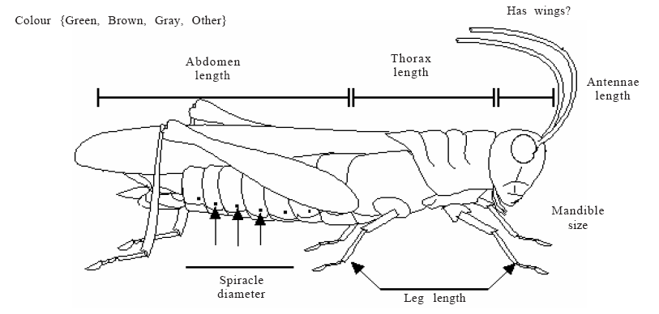
Fig. 3.3: Measuring features for domain of interest

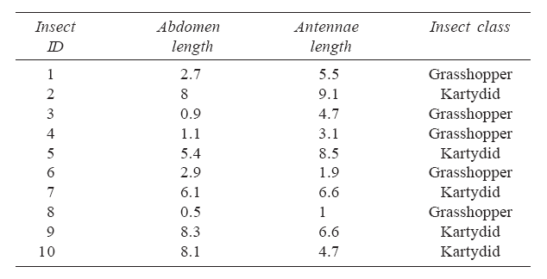
Table 3.1: Feature data set

3.8 Types of features
Features come in a variety of types that can be distinguished by the amount of information that they encode. They are briefly reviewed here starting with the “simplest” (those that carry the least information to those that carry the most information.)

    - Nominal variables: Essentially, these are no more than labels identifying unique entities. Personal names are nominal labels identifying unique individuals. So too are order numbers, serial numbers, tracking codes and many other similar labels.

    - Categorical variables: These are group labels identifying groups of entities sharing some set of characteristics implied by the category. In addition to personal names, all readers of this book belong to the category of humans.

    - Ordinal variables: These are categories that can be rationally listed in some order. Examples of such categories might include small, medium, and large or hot, warm, tepid, cool, and cold. Notice that neither nominal nor categorical variables can be ordered; they are simply unordered labels for single entities and groups of entities, respectively.

    - Interval variables: These are ordinal variables in which it is possible to determine a distance between the ordered categories. However, their intervals may well be arbitrary, as in a temperature scale. Additive distances between equidistant points are meaningful, but ratios aren’t. For instance, there are 10 degrees between 20 and 30 degrees, and between 110 and 120 degrees. However, 50 degrees isn’t twice as hot as 25 degrees, on either Celsius or Fahrenheit scales.

    - Ratio variables: These are interval variables in which ratios are valid, and which have a true zero point. An example is a bank account. The zero point is an empty account. The ratio between Rs. 10 and Rs. 20 is 1 to 2, and Rs. 20 is twice Rs. 10. The ratio between Rs. 100 and Rs. 200 is also 1 to 2, and Rs. 200 is twice Rs. 100. Same ratio implies to same relationship.
As far as mining algorithms are concerned, they don’t distinguish between nominal and categorical variable types, although the miner may well have to. Mining algorithms are also insensitive to the interval/ratio distinction, although once again a miner may need to be sensitive to the distinction. Thus, as far as mining algorithms are concerned, variables are unordered labels, ordered labels or continuous numbers. This means that algorithm sensitivity can be described as nominal, ordinal or numeric, respectively. Algorithms described as having nominal sensitivity are not sensitive to any ordering, but only to the joint frequency of occurrence between labels. The labels may actually be continuous numbers, but the algorithm regards them, or more likely bins of them, as nominal labels. Ordinally sensitive algorithms are sensitive to the order in which values occur, but extract no meaning from the distances between values. Thus, for such an algorithm, the fact that there is a gap between 1 and 2 is neither more nor less significant than the fact that there is a gap between 10 and 100. The size of the gap is quite irrelevant. Algorithms described as having a numeric sensitivity are sensitive to the distance between values, and for them the difference in distance between 1 and 2, and 10 and 100 makes a difference even if no values fall in between [6].
3.9 Ways to Machine Learning
There are two main methods through which machines can be made to learn, either they should be provided with some experience data or they will have to learn on their own by analyzing the trend of data. The two main classes of machine learning include the supervised learning algorithms and unsupervised learning algorithms.
- Supervised learning
In supervised learning, the machine is provided with a set of examples which are actual experiences which occurred to humans or observed in some other way. Here there is a label associated with each example. It is supposed to be the answer to a question about the example. If the label is discrete, then the task is called classification problem – otherwise, for real valued labels we speak of a regression problem. Based on these examples, the machines can predict the answer for other cases before they are explicitly observed. Hence, machine learning is not only a question of remembering but also of generalization to unseen cases.
- Classification learning: In this case the learning scheme takes a set of classified examples from which it is expected to learn a way of classifying unseen examples. The classification is done based on certain rules. It is a fact that the success of the algorithm depends on the clarity of example sets given to the machine while learning. Let’s take a simple classification problem. Assume we have two classes of graphs as shown in figure 3.4. By analyzing the figure it won’t be difficult for one to identify the rule based on which the classification is done in this case. As said previously the efficient classification is all based on how intelligently the rule is chosen. So try choose an intelligent rule for our example!
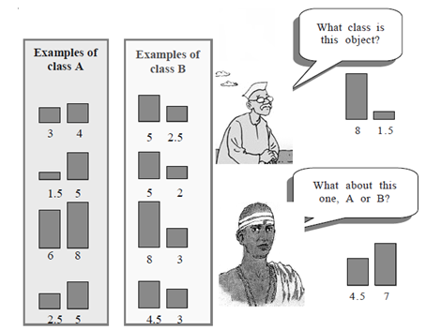
Fig 3.4: Classified set of bar graphs

Yes! The rule is “If the left bar is smaller than the right bar it belongs to class A , otherwise it belongs to class B” [6].
A practical application of classification: Consider a bank that gives loans to its customers. The bank would obviously find it useful to be able to predict which new customer would be a good investment and which one would not. Using data collected about the previous customers, the bank would like to know the attributes that make a customer a good investment or a bad investment. What is required is a set of rules that partition the data into two exclusive groups—one of good investments and the other of bad investments. Such rules are called classification rules as they classify the given data into a fixed number of groups. The data on old customers (for whom the group that they belong to is known) is called the training set from which the classification rules are discovered. The classification rules can then be used to discover as to which group a new customer belongs to.
- Regression Learning: Regression or curve fitting is a statistical operation that attempts to determine the relationship between one dependent variable (usually represented as ‘Y’) and a series of other independent variables. This type analysis basically tries find out equation of a curve or a line which closely represent the trend of data. Hence the possibility of correctly predicting the forthcoming data is enhanced. The two basic types of regression are linear regression and multiple regression. Linear regression uses one independent variable to explain and/or predict the outcome of Y, while multiple regression use two or more independent variables to predict the outcome of Y [1].
Linear Regression: Y = a + bX + u 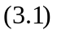
Multiple regression comes handy when pattern in the data cannot be represented with a straight line. Here more predictors are used rather than just one, Transformations are applied to the predictors, and Predictors are sometimes multiplied together and used as terms in the equation E.g.
Multiple Regression: Y = a + b1(X₁) + b₂(X₂) + b3(X₃) + ... + B_{t}(X_{t}) + u 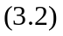
In 3.2 , Y is the variable that we are trying to predict, X is the variable that we are using to predict Y, a is the intercept, b is the slope and u is the regression residual. Regression analysis is widely used for prediction and forecasting, where its use has substantial overlap with the field of machine learning. Regression techniques have long been central to the field of economic statistics (“econometrics”). Increasingly, they have become important to lawyers and legal policy makers as well.
- Association rule learning: This is a type of learning based on the assumption that ideas and experiences reinforce one another and can be linked to enhance the learning process. This type of learning basically aims at analyzing the trend of data and finds out hidden rules which the data values closely follows. Here any association between features is sought, not just the ones that predict a particular class value. For example consider the following super market sales records culled from historical business data shown in Table 3.2. The set of items under study includes Rice, Egg, Fish, and Milk.
Date & Transaction ID | Rice | Egg | Fish | Milk
Monday | Yes | Yes | No | Yes
Tuesday | No | Yes | No | No
Wednesday | Yes | Yes | No | Yes
Thursday | No | No | No | Yes
Friday | Yes | No | Yes | No
Table 3.2: Instance of supermarket sales record
Form studying the table 3.2 one of the rules which the supermarket sales data follows is, if a customer buys Rice and Egg then he will not buy Fish. But note that this example is extremely small. In practical applications, a rule needs a support of several hundred transactions before it can be considered statistically significant, and datasets often contain thousands or millions of transactions.
Association rule learning is a popular and well researched method for discovering interesting relations between variables in large databases. Association rule learning is also used for discovering regularities between products in large scale transaction data recorded by using point-of-sale (POS) systems in supermarkets.

Note
When a baby cries, the mother picks the baby up to comfort it. The baby learns to associate crying with being picked up and will therefore cry whenever it wants to be picked up even if there is no discomfort. This is called learning by stimulus-response (S-R) association.

- Unsupervised learning
While the supervised learning methodology tries to generalize events based on examples, unsupervised learning typically tries to uncover hidden regularities or detect anomalies in the data. One of the widely accepted unsupervised algorithm is clustering

- Clustering: Data clustering refers to the method of grouping data into different groups or classes based on their similarity of features. So, the goal of clustering is to determine the intrinsic grouping in a set of unlabeled data. It should be kept in mind that the ultimate success of clustering depends on selection of features based on which the clustering is done. Hence there is a possibility of incorrect grouping. The figure 3.5 say it all.
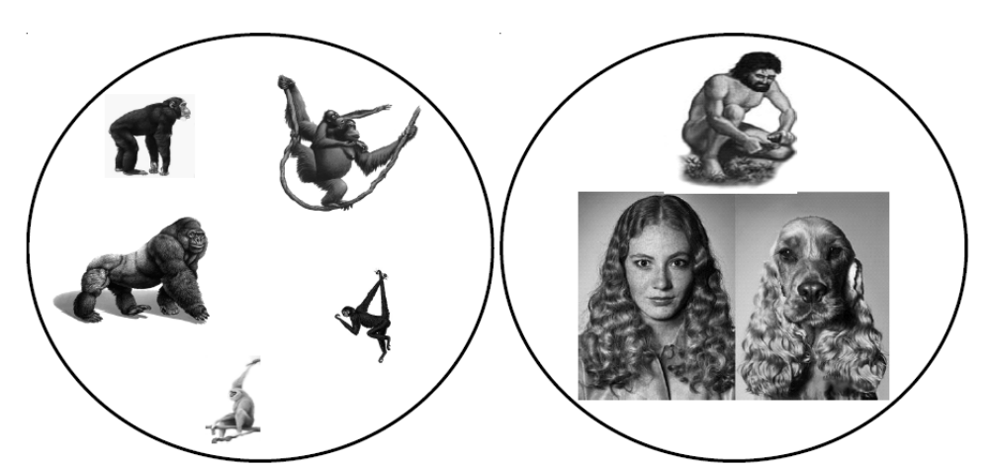
Fig 3.5 : Natural grouping based on similarity (Printed with permission from [6])

There are two main types of clustering techniques, those that create a hierarchy of clusters and those that do not. The hierarchical clustering techniques create a hierarchy of clusters from small to big. The main reason for this is that, as was already stated, clustering is an unsupervised learning technique, and as such, there is no absolutely correct answer. For this reason and depending on the particular application of the clustering, fewer or greater numbers of clusters may be desired. With a hierarchy of clusters defined it is possible to choose the number of clusters that are desired. At the extreme it is possible to have as many clusters as there are records in the database. The two main types of hierarchical clustering algorithms are Agglomerative clustering (It start with as many clusters as there are records where each cluster contains just one record. The clusters that are nearest each other are merged together to form the next largest cluster) and Divisive clustering (This techniques take the opposite approach from agglomerative techniques where initially all the records are in one cluster and then they are split into smaller pieces).
There are two main non-hierarchical clustering techniques. Both of them are very fast to compute on the database but have some drawbacks. The first are the single pass methods. They derive their name from the fact that the database must only be passed through once in order to create the clusters (i.e. each record is only read from the database once). The other class of techniques is called reallocation methods. They get their name from the movement or “reallocation” of records from one cluster to another in order to create better clusters. The reallocation techniques do use multiple passes through the database but are relatively fast in comparison to the hierarchical techniques.
Note
Hierarchical clustering has the advantage over non-hierarchical techniques in that the clusters are defined solely by the data (not by the users predetermining the number of clusters) and that the number of clusters can be increased or decreased by simple moving up and down the hierarchy.

3.10 Machine Learning Algorithms

- Traditional Learning Algorithms

- Statistics
Statistics is a branch of mathematics concerning the collection, analysis, interpretation or explanation, and presentation of data. Usually statistics is considered to be one of those scary topics in college right up there with chemistry and physics. However, statistics is probably a much friendlier branch of mathematics because it really can be used every day. Statistics was in fact born from very humble beginnings of real world problems from business, biology, and gambling! The two fields in statistics are descriptive statistics which is used to summarize or describe a collection of data; In addition, patterns in the data may be modeled in a way that accounts for randomness and uncertainty in the observations which is called inferential statistics. Inference is a vital element of scientific advance, since it helps in the prediction of values or events. Statistics also comes handy when it comes to finding out the value of an unknown function at a new point given the values of this function at a set of sample points.
Statistical methods for dealing with these problems can be considered instances of machine learning because the decision and estimation rules depend on a corpus of samples drawn from the problem environment [4]. Bayesian Networks is one of the widely used statistical techniques. Linear discriminant analysis (LDA) and the related Fisher's linear discriminant are simple methods used in statistics and machine learning to find the linear combination of features which best separate two or more classes of object (Friedman, 1989). When dealing with categorical variables, the equivalent technique is Discriminant Correspondence Analysis. And Bayesian networks are the most well known representative of statistical learning algorithms.
- Naive Bayes classifiers

A Bayesian Network is a graphical model for probability relationships among a set of feature variables (see Figure 3.6). The Bayesian network structure S is a directed acyclic graph (DAG) and the nodes in S are in one-to-one correspondence with the features X. The arcs represent casual influences among the features while the lack of possible arcs in S encodes conditional independencies [9].
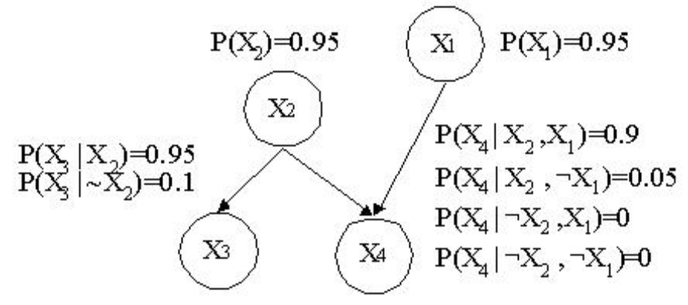
Fig 3.6: Example structure of Bayes Network
Naive Bayesian networks are very simple Bayesian networks. Naive Bayes model assumes that all variables contribute towards classification and they are mutually independent. Even though the assumption that, ‘the variables are uncorrelated’ is unrealistic for most of the datasets it gives surprisingly good results for many practical datasets. The independence model (Naive Bayes) is based on estimating R which is obtained from the following relation 3.3.

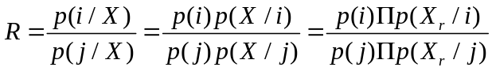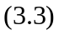

Comparing these two probabilities, the larger probability indicates that the class label value that is more likely to be the actual label i.e. if R>1: predict goes with class I else it will predict the class as j.
The major advantage of the naive Bayes classifier is its ability to training quickly. In addition, since the model has the form of a product, it can be converted into a sum through the use of logarithms – with significant consequent computational advantages

- k-Nearest Neighbor Classification
Nearest neighbor is a prediction technique that is quite similar to clustering. Its essence is that in order to predict what a prediction value is in one record, look for records with similar predictor values in the historical database and use the prediction value from the record that is “nearest” to the unclassified record. K-Nearest Neighbor is arguably the simplest classification method introduced by Cover and Hart in 1967 [3]. The motivation of such a classification rule goes back to prehistoric times where the idea is that, ‘things that look alike must be alike’.
Unlike other classification algorithms K-Nearest neighbor method do not construct a classification model from data, it performs classification by matching the test instance with K closely matching training examples, and a label is given to the test point by a majority vote between the k examples. Even though this method is highly intuitive, simple and produces remarkably low classification errors, it is computationally expensive and requires a large memory to store the training data. The probability of error of the nearest neighbor method is bounded by twice the Bayes minimum probability of error [4].
As shown in the following picture, we want to identify the class lable of a unknown record. In a set of training data, the class lable of other data objects are known. Also the number of K is given before classification. The major steps to perform K-Nearest Neighbors classification are:

- Compute the eucledian distance of the unknown data points to other example data points.
- Identify k nearest neighbors based on distance metric. Choosing a proper K value is important to the performance of K-Nearest Neighbor classifier. If k value is too large, it causes misclassification and if k is too small it will result in over fitting because of noise in the training data set.
- Use class labels of nearest neighbors to determine the class labels of unknown record. If there is one class label in the neighbors, then the unknown record is assigned to the same class labels. If the neighbors have more than one class labels, then the class label of unknown record is determined by taking majority vote.

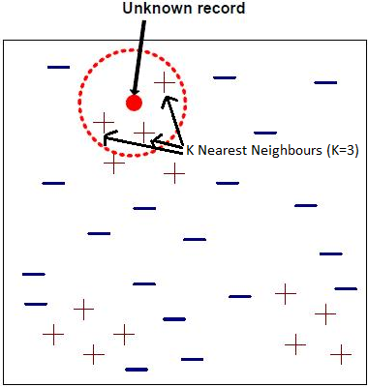
Fig 3.7: K Nearest Neighbours
In this case, we have assumed k=3. The unknown record is assigned a label which is the label for majority among the 3 neighbors. Thus here the unknow record is assigned a label “+” for majority of its neighbours are having “+” as the label.
- Neural Network
The concept of a neural network appears to have first been proposed by Alan Turing in his 1948 paper "Intelligent Machinery, A Heretical Theory". Turing contends that it may be possible to construct a machine in which there would be an element of randomness and an analogue of the pleasure principle of psychology, that could be taught, and that could eventually be more intelligent than humans [13].

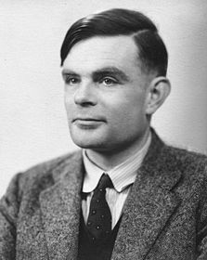
Fig 3.8: Alan Turing

Artificial neural networks are computational models of nervous systems. It basically has three layers Input layer, middle/hidden layer and output layer with multiple number of neuron/nodes in each of the layers. Here all the input layer nodes are connected to the middle layers and all the middle layer nodes are connected to all output layer nodes (The figure 3.9 shows the case where only one output node is present). All the connection will have a synaptic weight associated with it which controls the amount of information which is transferred through the link. The model can accept as many input parameters and provide as many outputs which may be Boolean or Numeric. The only requirement of neural network is that, it needs to be trained (adjustment of synaptic weights) before installation.

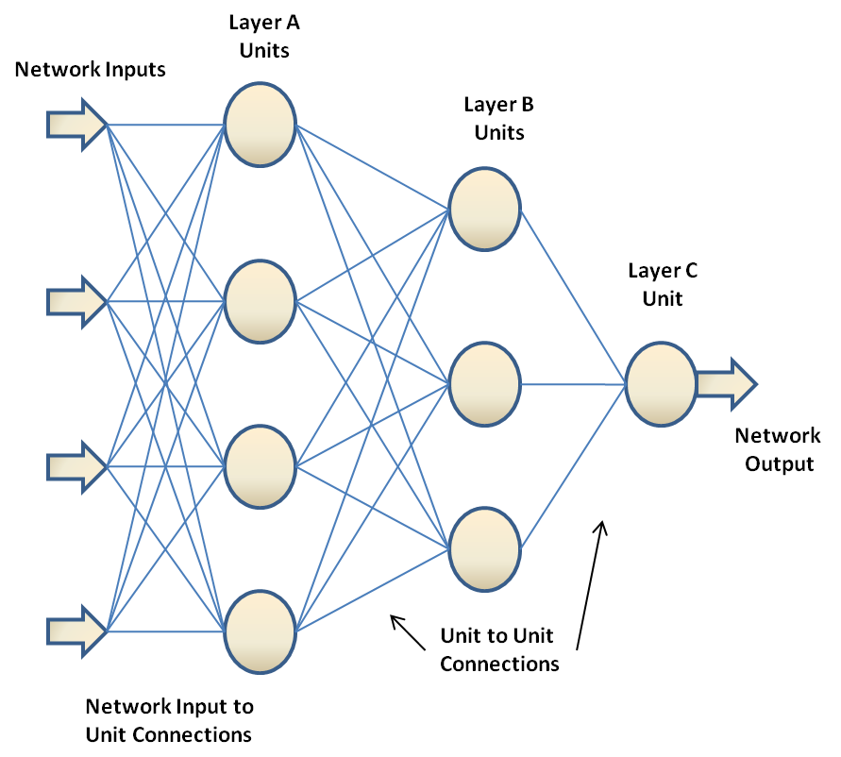

Fig 3.9: Model of Neural Network

A further boost to their popularity came with the proof that they can approximate any function mapping via the Universal Approximation Theorem [5]. Now neural network is one of the most commonly used classification methodology. For a neural network model since the only control over the output is through the weights, the classifier can take any complex shape. This provides neural network the ability to represent any complex function.

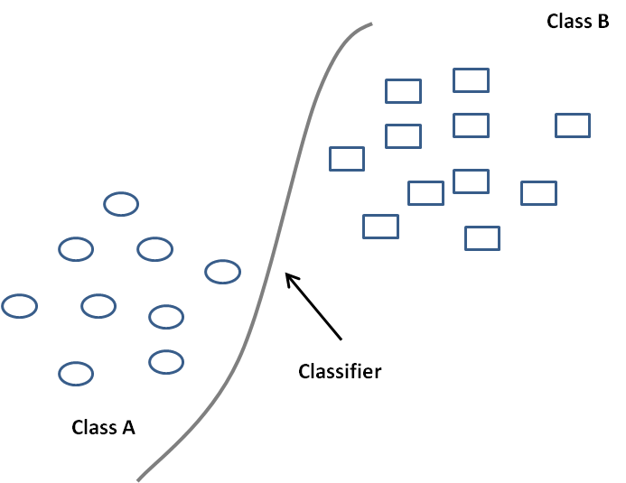
Fig 3.10: Classifier obtained with neural network

As mentioned earlier, as far a neural network based classification is concerned there is very less control over the classifier shape. Hence the possible classifier can be like one shown in figure 3.10. This results in more generalization error. I.e. the possibility of misclassification when a new data point comes is increased.

- Decision Trees

A decision tree is a tree based knowledge representation methodology used to represent classification rules. Here the internal nodes represent attributes associated with the objects being classified while the leaf nodes represent the class labels or patterns. The main purpose of the decision tree is to expose the structural information contained in a dataset. The algorithms solve the classification problem by repeatedly partitioning the input space, so as to build a tree whose nodes are as pure as possible (that is, they contain points of a single class). Classification of a new test point is achieved by moving from top to bottom along the branches of the tree, starting from the root node, until a terminal node is reached. A decision tree can be used for data exploration in one or more of the following ways:

- Data Description: To reduce a volume of data by transforming it into a more compact form and hence preserve the essential characteristics and provides an accurate summary.
- Data Classification: Discovering whether the data contains well-separated classes of objects such that the classes can be interpreted meaningfully in the context of a substantive theory.
- Data Generalization: Uncovering a mapping from independent to dependent variables that is useful for predicting the value of the dependent variable in the future.

For small datasets decision trees can be said as the best or effective classification scheme. But even for a small training dataset the decision tree can be quite large and thus opaque. Thus for a decision tree computational complexity scales unfavorably with the number of dimensions of the test data hence demands larger memory for storage.
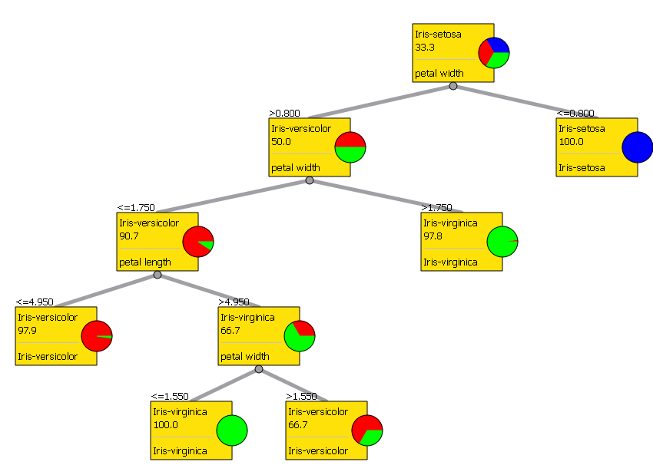

Fig 3.11: Classification Tree obtained for Iris data set
Let’s consider an example. The figure 3.11 shows the classification tree obtained for Iris dataset. This data set is created from analyzing three Iris plant species. As seen in the figure 3.11, the initial split is done based on petal width. The process will continue until the pure nodes are obtained. So when a new Iris data point comes for classification it will start from the root level rules and depending on the classification done on the root level it goes to any one of the lower levels, where they will have to face another set of classification rules. This continues until the input data point is classified to any one of the Iris plan species
- New Generation Learning Algorithms
Kernel-based techniques (such as support vector machines, Bayes point machines, kernel principal component analysis, and Gaussian processes) represent a major development in machine learning algorithms.
- Support Vector Machines
Support vector machines (SVM) are a group of supervised learning methods that can be applied to classification or regression. Support vector machines represent an extension to nonlinear models of the generalized portrait algorithm developed by Vladimir Vapnik. The SVM algorithm is based on the statistical learning theory and the Vapnik-Chervonenkis (VC) dimension introduced by Vladimir Vapnik and Alexey Chervonenkis [14].

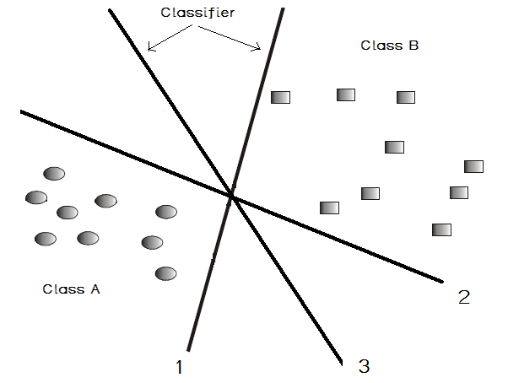
Fig 3.12: Data points & three possible hyper planes

To understand the concept of SVM let’s consider data points belonging to two classes as shown in the figure 3.12. The two sets can be classified by drawing a hyper plane (for two dimensional cases it is a line). But as you can see, there are infinite possibilities by which a hyper plane can be drawn to achieve this separation. In the figure 3.12 we have taken three of the possible set of classifiers (hyper planes). If you see the figure, one can be easily interpret that, the classifier 1 and classifier 2 are no good classifier. This is because the generalization error is much greater in these cases. But classifier 3 is drawn such that it keeps the generalization error minimum. By minimum generalization error, we mean that when new examples or data points arrive for classification, the chances of making error in out prediction should be minimum. This is the basic idea behind the SVM methodology. I.e. SVM classifies the input data by using a maximally separating hyper plane. The process of obtaining the slope, y-intercept etc. of this optimal separating line is called as Training.
If for a data set, the possibility of obtaining a linear classifier is minimal, [i.e. In those cases where if we try for a linear classifier, generalization error will be large] Support Vector Machines work by mapping the training data into a feature space by the aid of a so-called kernel function and then separating the data using a large margin hyper plane [6]. This pictorial representation of this logic can be seen in the figure 3.13.
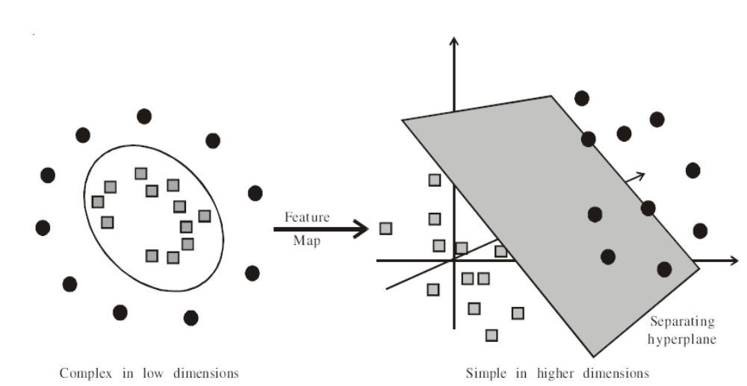
Fig 3.13: Non linear classifier
Generally, SVMs and neural networks tend to perform much better when dealing with multi-dimensions and continuous features. However For neural network models and SVMs, a large sample size (example datasets) is required in order to achieve its maximum prediction accuracy whereas NB may need a relatively small dataset.
- Boosting
The concept of boosting applies to the area of predictive data mining, to generate multiple classifiers (for prediction or classification), and to derive weights to combine the predictions from those models to obtain the final prediction. In other words boosting will generate a sequence of classifiers, where each consecutive classifier in the sequence is an "expert" in classifying observations that were not well classified by those preceding it. During deployment (for prediction or classification of new cases), the predictions from the different classifiers can then be combined (e.g., via voting, or some weighted voting procedure) to derive a single best prediction or classification. Boosting techniques have been used on very high dimensional data sets and can quite easily deal with than hundred thousands of examples [10].

AdaBoost is very popular and perhaps the most significant, as it was the first boosting algorithm that could adapt to the weak learners. However, there are many more recent boosting algorithms such as LPBoost, TotalBoost, BrownBoost, MadaBoost, and LogitBoost.[2]

3.11 Summary
Machine Learning is a natural outgrowth of the intersection of Computer Science and Statistics. Machine learning algorithms outperformed all other approaches that have been attempted to date. This chapter explains the different methods/algorithms utilized in machine learning with simple examples.

Questions:

  - Explain the relation between machine learning and data mining?
  - What do you refer by the term machine learning and what makes machine learning an inevitable tool of today?
  - What do you think are some important holy grails of machine learning?
  - What are feature in the context of machine learning and why are they important?
  - Give an introduction about various machine learning algorithms? Is there any algorithm that you can say as the most efficient? If yes also specify why?

References

[1] Alan O. Sykes, ‘The Inaugural Coase Lecture : An Introduction to Regression Analysis.
[2] Boosting - http://en.wikipedia.org/wiki/Boosting.
[3] Cover T M and Hart P E, ‘Nearest neighbor pattern classification’, IEEE Trans. Inform. Theory, 1967.
[4] Gunnar R¨atsch , ‘A Brief Introduction into Machine Learning’.
[5] Haykin. Neural Networks: A comprehensive foundation, 2nd Ed. Prentice-Hall, 1999. D.P. Helmbold, D.D.E. Long, T.L. Sconyers, and B. Sherrod. Adaptive disk spin-down for mobile computers. Mobile Networks and Applications, 5(4):285–297, 2000.
[6] K.P. Soman. Shyam Diwakar. V. Ajay, ’Insight into Data Mining. Theory and Practice’ with CD ROM,. 510.78. S6 I6. 206291 2. 188.
[7] Machine learning - http://en.wikipedia.org/wiki/Artificial_intelligence
[8] Nils J. Nilsson, ‘INTRODUCTION TO MACHINE LEARNING - AN EARLY DRAFT OF A PROPOSED TEXTBOOK’, Robotics Laboratory, Department of Computer Science Stanford University, Stanford, CA 94305.
[9] Pang-Ning Tan, Michael Steinbach, Vipin Kumar, ’Introduction to Data Mining’, Published by Addison Wesley.
[10] StatSoft Electronic Statistical Textbook :- http://www.statsoft.com/textbook/data-mining-techniques.
[11] Tom M. Mitchell, ‘Machine Learning’ McGraw-Hill 1997. ISBN: 0070428077.
[12] Tom M. Mitchell, T. M. 2006. The discipline of machine learning. Tech. rep. CMU-ML-06-108, Carnegie Mellon University.
[13] Turing, A.M. (1951b), 'Intelligent Machinery, A Heretical Theory', Manchester University Lecture, in Copeland (1999).
[14] SVM – Support Vector Machines - http://www.support-vector-machines.org/

